**2020 Officers & Directors**

**President**

Jeremy Keller, SRA, AI-RRS

Vice President

Karen Olson, MAI

Secretary/Treasurer

Sarah Cunningham, SRA

**Directors**

Regional Representative

Committee Chairs

Gov’t Relations:

Candidate Guidance:

Chapter Executive Director

Shauna Gehring, SRA

(515) 419-6076

iachap@yahoo.com

**President’s Message**

President’s Message

June 2020

I want to start by thanking Karen Olson, MAI and Sarah Cunningham, SRA for their hard work helping me to lead our chapter through a very successful year. Both have been helping to make sure we had a great year and have a great start to next year.

I also want to thank Shauna Gehring, SRA for her hard work and dedication to our chapter. She does so many things for our Chapter and especially this year and how crazy different it was. I could have never done it without her.

So, what a year! I am so thankful we were able to get in our USPAP offering in both Iowa City and Des Moines before the whole Covid-19 Virus hit hard. Unfortunately, we had to cancel all our other education, but don’t worry we will have them next year as they are great classes and we are very excited to put them on. We will have our Novemberfest in Des Moines so please make sure you sign up for that as I am sure we all will be very anxious to go out and mingle (at a safe distance) by then. Again, I am so thankful Shauna was able to reschedule all our other education on this crazy year and I am sure she will have the schedule ready to go by the Novemberfest class.

All else is going as well as it can and I hope you have reached out to us if you have had any questions about anything appraisal related. National has put out some webinars and discussions concerning appraising during this pandemic and I hope you watched those. We are here to help in any way our members need so please don’t be afraid to reach out to us.

I am very happy to say we have confirmed multiple designations this year and hope to have some more confirmed by the end of the year.

Please reach out to Shauna or I if you have any classes you would like to see us put on or any questions about the chapter or the region or national. We would be happy to answer these and please reach out if you would like to be considered to help out with leadership. We are always looking for new blood to help lead this wonderful chapter and organization.

I am very excited for the rest of this year and to hopefully see you all at Novemberfest!

* Jeremy Keller, SRA/AI-RRS

**USPAP Class Picture**

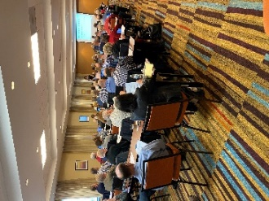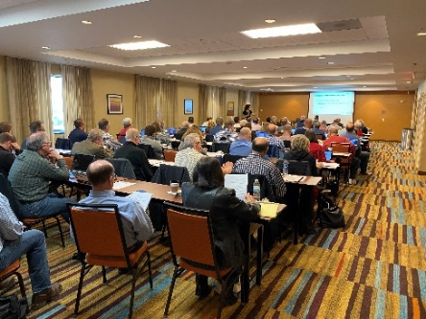

**COVID-19 Update**

By Sarah Cunningham

In March, the state of Iowa was struck by the Coronavirus pandemic. Governor Kim Reynolds has recently opened portions of the state and certain businesses in an effort to stabilize the economy. However, many business, meetings, and events will remain closed, cancelled or postponed throughout the upcoming summer months. Changes to the appraisal process, including more exterior-only inspections, as well as desktop appraisals, have been made in an effort to increase social distancing. To keep up-to-date with the Covid-19 pandemic and appraisal guidelines, see the links below.

[Center of Disease Control](https://www.cdc.gov/coronavirus/2019-ncov/cases-updates/summary.html)

[Appraisal Institute Coronavirus (Covid-19)](https://www.appraisalinstitute.org/news/coronavirusupdate/)

[Fannie Mae Lender Letter 2020-06](https://singlefamily.fanniemae.com/media/22721/display)

**Iowa Chapter Education 2020**

**NOVEMBERFEST: Artificial Intelligence, AVMs, and Blockchain: Implication for Valuation (4 Hrs)**

November 4, 2020

Jasper Winery: Come socialize, have lunch, do some wine tasting and get 4 hrs CE. All included in the price. $135

[Iowa Chapter of the Appraisal Institute](http://www.aiofiowa.org/Education/)

[Online Education](https://ai.appraisalinstitute.org/eweb/DynamicPage.aspx?webcode=AIEducationSearch): Learn at your own pace anytime, anywhere.  
Top-notch Appraisal Institute courses and seminars come straight to your desktop with online education! Learn from any computer anywhere, whenever you have time. It’s easy, convenient and a great way to get the education you want.

[Appraisal Institute Education](https://www.appraisalinstitute.org/education/)

